EXERSICE 3
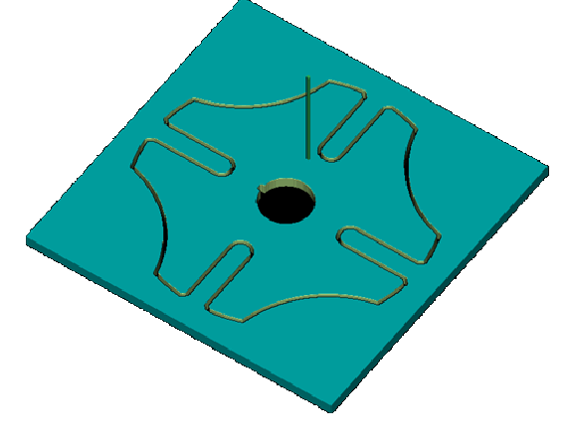

NAME:TANABAI RAJPUT
USN:2GI20ME076
SIGNATURE:

